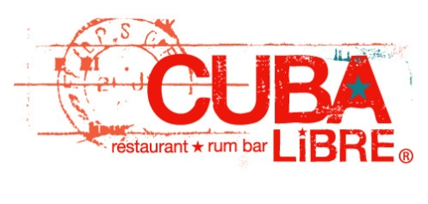
ACU HOLIDAY PARTY 2015

First Wave
Served family style
Cuban Bread Basket
Banana bread, guava cream cheese hojaldre, crispy churro, coconut-berry muffin, chocolate muffin.
Mango butter, coconut-lime preserve, guava marmalade

Pineapple Guacamole Cubano
Avocado, grilled golden pineapple, roasted jalapeños, fresh lime juice, extra virgin olive oil.
Crispy plantain chips

Spinach and Manchego Buñuelos
Manchego cheese and spinach puffs. Goat cheese-ranch sauce and organic olive oil

Coconut Crab Fritters
Jumbo lump crabmeat, fresh grated coconut, peppers, fresh herbs.
Sweet chili dipping sauce

Shrimp Ceviche
Cuban style shrimp cocktail. Latino cóctel sauce and avocado salsa

Mamá Amelia’s Empanadas
De la Casa: Hand-chopped chicken, corn, Jack cheese
Eggplant: Diced eggplant sautéed with capers, olives, Tio Pepe sherry and raisins
Aji-sour cream dipping sauce

Second Wave
Choose one
Arroz a la Cubana
One of the most traditional dishes from Cuba.
Steamed white rice, two over easy eggs, maduros, enchilado Creole sauce

Canela Waffle
“True cinnamon” waffle, fresh sliced bananas, citrus-maple syrup. Whipped cream

French Toast a la Cubana
Vanilla custard soaked brioche bread.
Maple syrup and panela soaked sweet plantains. Whipped cream

Panqueques
Two cornmeal pancakes and crispy bacon. Dark rum-molasses syrup and mango butter

Levanta Muerto Seafood Soup
“Raise the Dead” with this coastal seafood soup overflowing
with shrimp, Baja Bay scallops, crabmeat and mussels.
Coconut milk fortified “Chino-Cubano” broth. Truffle oil

Dessert
Pastry Chef’s Favorites
Our pastry chef’s selection of favorite desserts, displayed in mini portions so you can try them all!

~The consumption of raw or partially cooked eggs, meat, fish or shellfish
may increase the risk of contracting food borne illness~
TOTAL PRICE IS $40.00 (COVERS TAX/GRATUITY/FOOD COST).
TEA/COFFEE/SOFT DRINKS/ICED TEA INCLUDED IN THE TOTAL.

